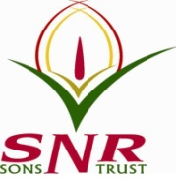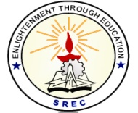**SRI RAMAKRISHNA ENGINEERING COLLEGE**

[Educational Service: SNR Sons Charitable Trust]

[Autonomous Institution, Accredited by NAAC with ‘A’ Grade]

[Approved by AICTE and Permanently Affiliated to Anna University, Chennai]

[ISO 9001:2015 Certified and all eligible programmes Accredited by NBA]

**VATTAMALAIPALAYAM, N.G.G.O. COLONY POST, COIMBATORE – 641 022**

**SREC – IP CELL**

**Date: 12.10.2021**

**Report on Webinar on IP Assets - Challenges and Guidelines:**

An webinar for the faculty of Sri Ramakrishna Engineering College has been conducted by SREC-IP Cell on 09.10.2021. Mr. Ganesan Natarajan, Senior Manager at Expleo Group, Bangalore, Karnataka, India was the chief guest and gave a talk on " IP Assets - Challenges and Guidelines".

Dr. M. S. Geetha Devasena, Professor/CSE and Head-IP Cell welcomed the gathering, The introduction to the resource person was given by Mr. S. Ranjithkumar, Assistant Professor/CSE. There were about 48 faculty members attended the online workshop and got benefitted out of it. Dr. R. Kingsy Grace, Associate Professor/CSE delivered the vote of thanks.

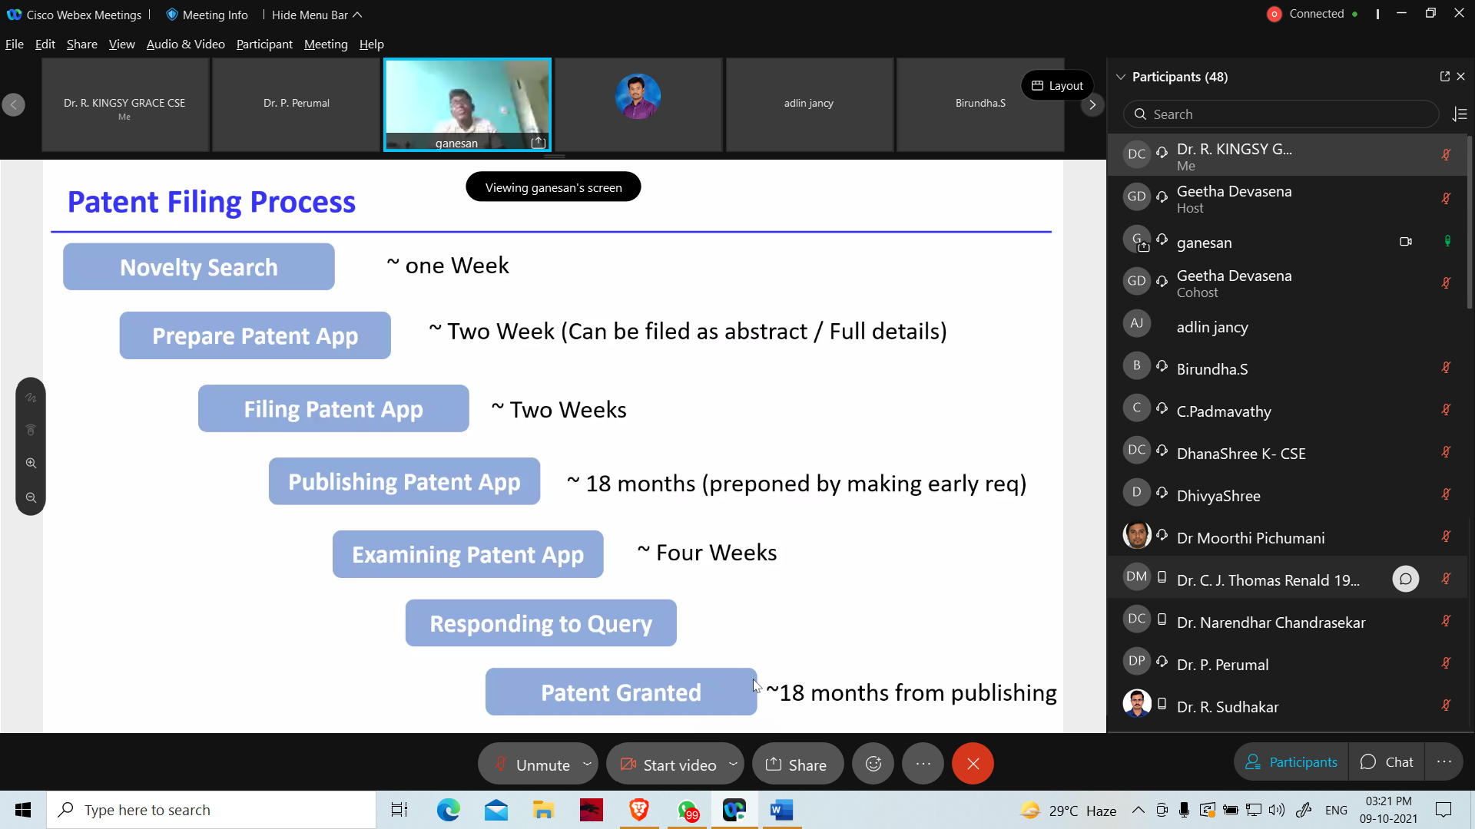

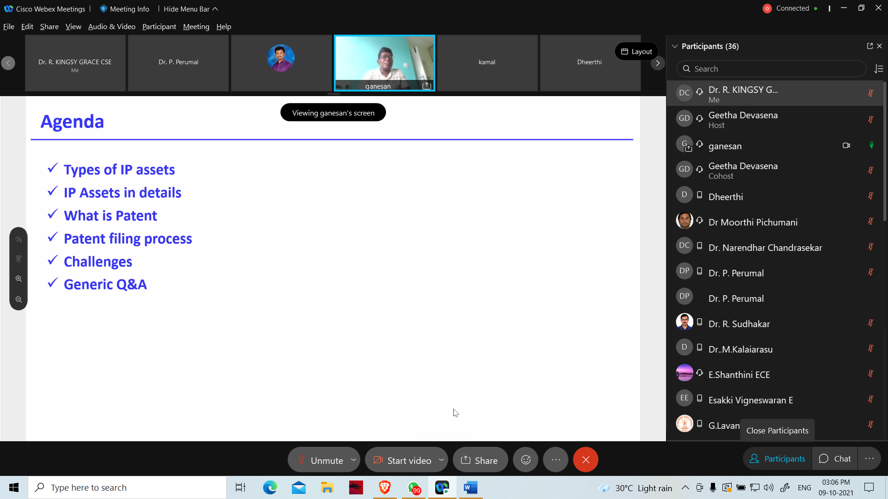

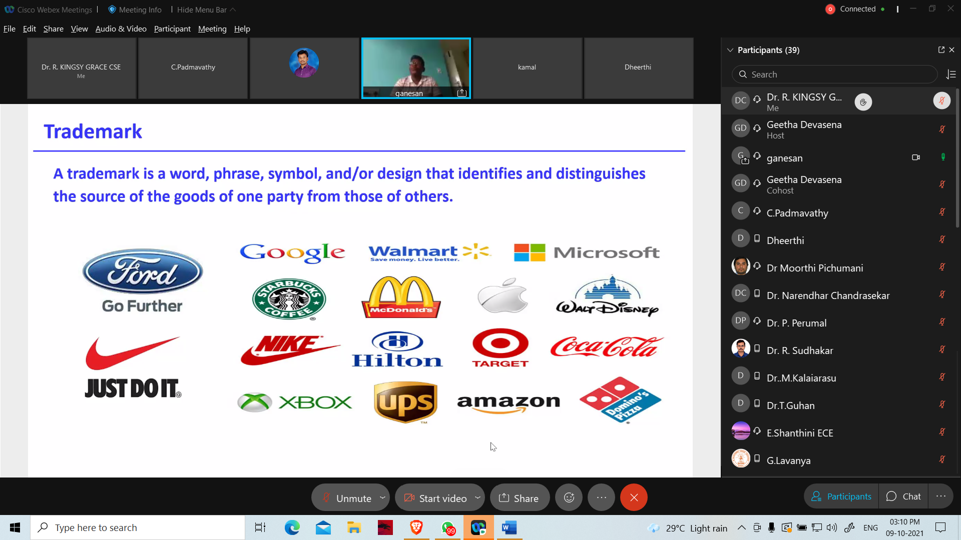

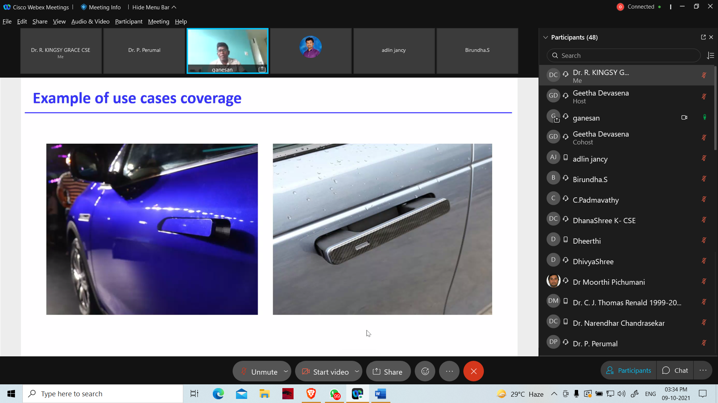

**HEAD – IP CELL**

**Dr. M. S. Geetha Devasena, P/CSE**